Infonique iSEB Expansion Board

1200 0050

Prepared by | Date | Version
Bing Ran | 14/10/2024 | 1.0

Abstract

This document provides detailed of Infonique expansion board 1200 0050 specification. We will mention it as expansion board from now onward.

Document History
Date | Rev | Modifier | Changes
14-Oct-2024 | 1.0 | Bing Ran | First Draft

Contents

Abstract 2
Document History 2
Contents 3
Table of Figures 4
Table of table 4
1 Introduction 5
1.1 PINOUT 5
1.2 Connectors 6
1.2.1 Power Input 6
1.2.2 Motor Connectors 6
1.2.3 Button 7
1.2.4 Infrared Receiver 7
1.2.5 RBG LED Connectors 8
1.2.6 Buzzer 8
1.2.7 Ultrasonic Sensor Connector 9
1.2.8 Bluetooth Connector 9
1.2.9 OLED Display Connector 9
1.2.9 AI Husky Lens Connector 10
1.2.10 IR Tracking Sensor Connector 10

Table of Figures
Figure 1 Top and bottom layer of expansion board 5
Figure 2 Power Connector 6
Figure 3 Motor Connectors 6
Figure 4 Button 7
Figure 5 Infrared Receiver 7
Figure 6 Example of infrared remote control 7
Figure 7 RBG LED 8
Figure 8 Example of round and strip LED 8
Figure 9 Buzzer 8
Figure 10 Ultrasonic Sensor Connector and HC-SR04 ultrasonic sensor 9
Figure 11 Bluetooth connector and HC-05 bluetooth module 9
Figure 12 OLED display connector and OLED display 9
Figure 13 AI Husky Lens Connector 10
Figure 14 Connector for IR tracking sensor 10

Table of table
Table 1 Expansion board pinout 5

1 Introduction

Infonique Expansion board to plug onto the Arduino UNO board. It operating voltage is base on Arduino UNO. It is about 5.7cm(L) x 5.3cm(W). It ables to drive
Figure 1 Top and bottom layer of expansion board

1.1 PINOUT
Pin | Function | Pin | Function
D0 | UART Rx | D10 | Right Motor Encoder A
D1 | UART Tx | D11 | Buzzer
D2 | Infrared sensor Rx/  IR Tracking Sensor A5 | D12 | Ultrasonic Echo
D3 | Right Motor Speed | D13 | Ultrasonic Trigger
D4 | Right Motor Encoder B | A0 | Left Motor Direction
D5 | Left Motor Speed | A1 | Right Motor Direction
D6 | Left Motor Encoder B | A2 | Button Input / IR Tracking Sensor A1
D7 | Left Motor Encoder A | A3 | IR Tracking Sensor A2
D8 | Bluetooth Tx | A4 | I2C SDA/IR Tracking Sensor A3
D9 | Bluetooth Rx | A5 | I2C SCL/IR Tracking Sensor A4
Table 1 Expansion board pinout

1.2 Connectors

1.2.1 Power Input
- Expansion board provide connector for batter.
- The input voltage limit base on Arduino board voltage regulator.
- There are positive and negative sign on the connector.
- The board will be damaged if connected wrongly.
- The on board pcb connector is JST B2B-XH-A.
- The mating connecter will be JST XHP-2.
Figure 2 Power Connector

1.2.2 Motor Connectors
- Expansion board provides 2 motor connectors which are right and left.
- It allows users to control 2 encoded DC motors simultaneously with motor drivers.
- It able to control two groups of speeds left and right.
- It able to control the direction of each motor.
- The on board pcb connector is JST B6B-XH-A.
- The mating connecter will be JST XHP-6.
Figure 3 Motor Connectors

Number | Pin
1 | M-
2 | 5v
3 | B
4 | A
5 | GND
6 | M+
Table 2: Pinout arragement for motor connector
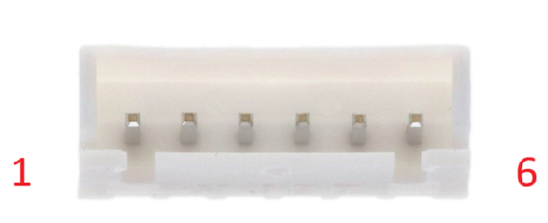Figure 4: Connect JST B6B-XH-A

1.2.3 Button
- Expansion board provide a button for user to explore digital input.
- Users have to short the jumper with 2.54mm jumper cap in order to work with the button.
- The button come with a pull up resistor internal pull up is not required.
- The figure below is showing the jumper and button.

Figure 5 Button

1.2.4 Infrared Receiver
- Manufacturer : Vishay Part Number : HS0038 Operating Frequency : 38kHz
- Able to receive the signal from infrared remote control.
- Users have to short the jumper with 2.54mm jumper cap in order to work with the button.
Figure 6 Infrared Receiver
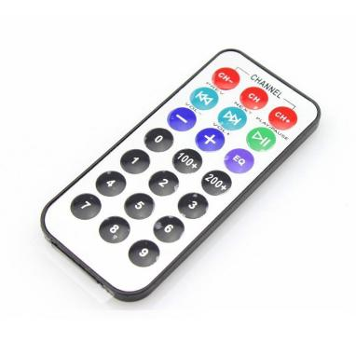
Figure 7 Example of infrared remote control

1.2.5 Buzzer
- Passive buzzer able to have different tone with change the frequency of the PWM signal.
Figure 8 Buzzer

1.2.7 Ultrasonic Sensor Connector
- Able to work with HC-SR04 ultrasonic sensor.
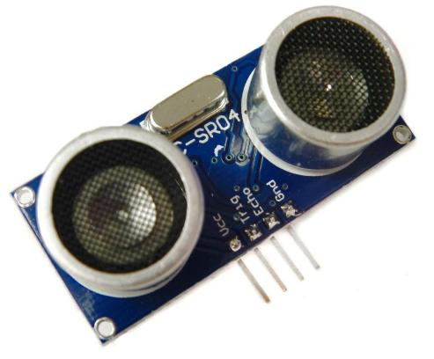
Figure 9 Ultrasonic Sensor Connector and HC-SR04 ultrasonic sensor

1.2.8 Bluetooth Connector
- Able to work with HC-05 Bluetooth module through serial communication.
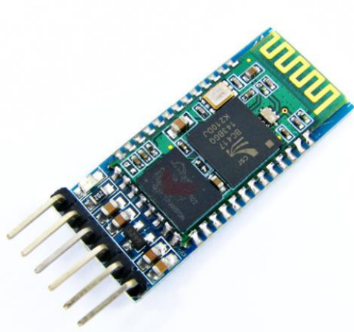
Figure 10 Bluetooth connector and HC-05 bluetooth module

1.2.9 OLED Display Connector
- Able to work with SSD1306 driver OLED display module through I2C communication.
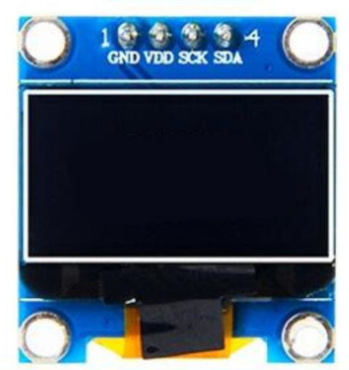
Figure 11 OLED display connector and OLED display

1.2.10 IR Tracking Sensor Connector
- Able to work with IR Tracking Sensor with A2,A3,A4,A5 ,5v and GND pin.
- IR receiver ,button and OLED display cannot work simultaneously with IR tracking sensor because they are using the same pins with IR tracking sensor.
- The remove the jumper cap for button and IR receiver is need in order to use IR tracking sensor
- The connector provided for IR tracking sensor is 2.54mm 6pin male pin.
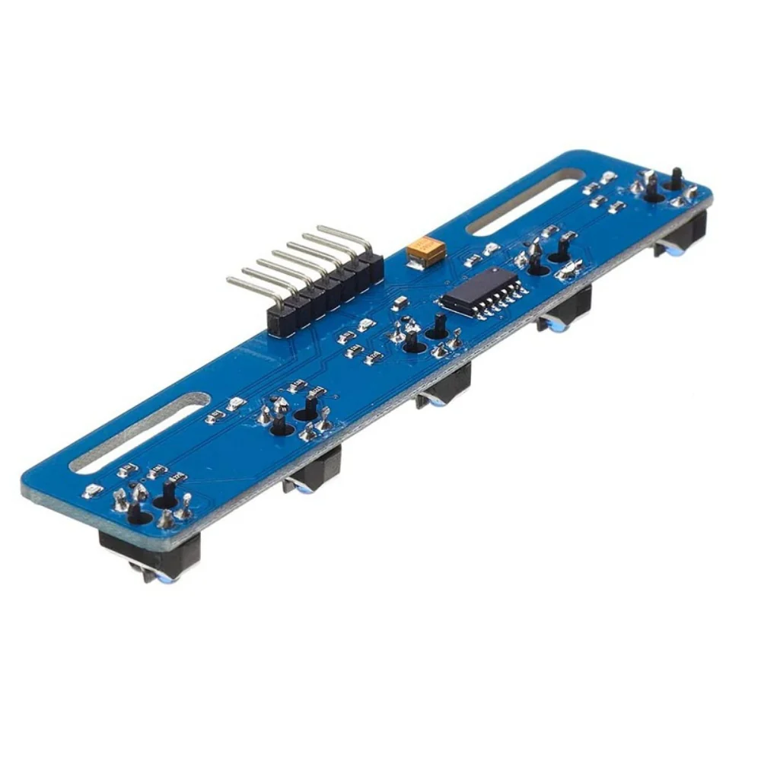
Figure 12 Connector for IR tracking sensor
Number | Pin
1 | Gnd
2 | Vcc
3 | Out1
4 | Out2
5 | Out3
6 | Out4
7 | Out5
Table 3: Pin arragement for IR tracking sensor from left to right

